**JINJA JOINT EXAMINATIONS BOARD**

**MOCK EXAMINATIONS 2022**

**BIOLOGY 2 P530/2**

**MARKING GUIDE**

SECTION A

•l For patient A, the antibody concentration increased/accumulated/raised, to the peak/highest concentration; immediately/at the time of vaccination; the antibody concentration in the body then decreased gradually/slowly with time to zero/completion; at 120days;

For patient B, after immunisatioñ the concentration of the antibody increased slowly /slightly/gradually; from 0 to 60 days; it then increased rapidly; to a maximum concentration; from 60 days to 90 days; from 90 days to 1 20 days; the concentration of remained at the peak for a few days; and then decreased very slightly;

1/2 mark for any 14 07 marks

(ii) In patient A there was accumulation/ presence of maximum concentration of the antibody while antibody was absent in patient B; immediately after the vaccination; This is because patient A was directly vaccinated by the antibody; while patient B received an Antigen vaccine;

Over the 1 20 days; the antibody concentration in patient A decreased slowly to zero; while that of Patient B increased slowly UP to 60 days; then increased rapidly to peak at 90 days; and after wards from 90 to 120 days it decreased very slowly;

This is because in patient A the antibody being a protein is broken down over time; in patient B, the introduction of antigen vaccine stimulates the lymphocytes to start producing antibodies slowly for the first 60 days.

The rapid increase from 60 to 90 days may be due to the infection which results in secondary response if the individual is attached by the pathogen in the vaccine;

 mgrk Q 12 mgrk$

(iii) Vaccine to patient A is an antibody; which is given /administered in enough amounts/concentrations; that can suppress the effects of the pathogen/parasites in case of infection; in early days after immunisation. However it IS used up completely over time; and this leaves the body unprotected; in case of flJtwre attack/infection by the parasite immunised against; Vaccine to patient B is an antigen; which stimulates thelymphocytes to start producing the antibodies; At the beginning days after immunisation; the concentration of the antibody is small or accumulate very slowly; and in case if infection at that time ; the development of a disease may not be prevented; However, any infection causes rapid production of antibody; and

the body ,has its own defence system to fight the pathogens/ parasites immunised/ vaccinated against;

mark @ 7 marks

(b) In primary response which occurred after first infection with pathogen/antigen; the antibödy concentration increased very slightly; and then increased gradually; to a lower peak; and decreased rapidly to a lower concentration in blood; while in secondary response which occurred after second infection/challenge with the pathogen/parasites/antigen; the antibody concentration increased very steeply/ rapidly; immediately after the infection to a higher peak/maximum concentration and it then decreased slowly/ gradually/slightly in the remaining period of time.

This is because in secondary response there are m.g.m.Q.!Y...-P-ggllž,• which produce antibodies immediately the pathogen /antigen gains entry into the body; and antibodies produced are stronger and last for a longer time than the antibodies produced in the primary response;

1/2 mark @ 06 marks

(ii) The aaqlutinins bind to the pathogens causing them to clump together which lead to their death;

The lysins bind to the pathogens causing them to disintegrate and die in a process called lysis;

The opsonins bind to the pathogens making it easier for phagocytes to engulf them;

The Antitoxins bind to pathogens and neutralise toxins they produce or from other sources;

1 mark @ 4 marks

(c ) Mild infections introduce the antigens/pathogens for the disease into our body but the disease may not develop to serious condition; However, pathogen provoke the body/ lymphocyte to start producing antibodies and memory B cells/ primary response to infections; Therefore in case of future infections/attack by the same pathogens; the antibodies are immediately and rapidly produced by the memory cells/secondary response OCCUS/ to counter the effects of the pathogens;

7 mark @ 4 marks

Total = 40 marks

SECTION B

2(a) Self pollination; s maintains the characteristics of the parental plants; but the reduced genetic variation; causes reduced fertility; and reduced resistance to diseases; and all members may be wiped out in case an epidermic, e.t.c;

Cross pollination; results in formation of hybrids that may show variation superior to those of the parentsTshow hybrid vigour such as increased growth rate and size; resistance to pests and harsh climatic cohdition such as long periods of dryness; increasing the chances of survival of organisations/plants produced by cross pollination.

1 mark for any 8 08 marks

 ( b) Dioecism /plant species with flowers of opposites sex developing on different plants. Pollination is only by cross pollination;

 Self incompartibility/Growth of pollen/growth of pollen tubes cannot OCCU on stigma of same flowers or flowers of the same plants;  Protogyny or protandry/maturation of stigma before pollen grains by the same plant/maturation of pollen grains before maturation of stigma of flowers on the same plant;

Stigma being above anthers hanging down wards;

 Presence of brightly coloured petals which attract external insect pollinators;

 Secretion of sweet smelling substances that attract insects' pollinators.  Strictly pollen grains attracting on insect pollinating agents;

1 mark @ 06 marks

( d) Seeds can be preserved and stored for a long period of time; This is because the conditions for their germination are known and can be controlled so that planting is done when crop growth is assured;

Seeds are small and easily distributed in large quantities from one place to another with no or very minimum spoilage;

Seeds are formed by fertilization; and plants developed from seeds may show hybrid vigour characteristics by advantageous features of crops such as increased growth rate; high yield/large fruit size; and high resistance to pests, and droughts;

1 mark @ for any 6 6 marks  Total 20 marks max

3(a) (i) A species is a group of organisms with similar characteristics/with similar morphological features; and interbreed among themselves to form fertile or viable offspring; 02 marks

(ii) Species extinction refers to when all the existing members of a species become completely wiped out such that there is not any surviving members.

(jii)Pest resurgence refers to when the residual population of pests Increases rapidly without check to worse levels than before after the natural predators as well as other pests had been killed by the non- specific pesticides; I mark

(b) (i) Land reclamation/ Deforestation;

 Application of pesticides

 Over fishing;

 Pouching;

 Disposal of wastes into water bodies.

Any 4 1 mark " 4 marks

(ii) Throughout breeding/selective controlled reproduction between genetically distant related individuals of a species or closely related species; new forms of plants species have produced;

Through inducing polyploidy in crops; new forms of plants/crops species are produced e.g in wheat plants;

Through excess use/application of pests and drugs /chemicals; resistant forms due to random mutation have emerged;

1 mark @ 06 marks

(c ) (i) Predation may cause evolution / emergence of preys with features that enable them to survive predation' These are selected for /survive better lat selective advantage and are perpetuated future generation; over time such preys may only exist after complete wiping out of the vulnerable preys;

(1 mark @ 3 marks)

(ii) This inborn behaviour in some animals /birds enables them to avoid the likely unfavourable condition in a given habitant' and they move places with suitable factors for survival increasing their chances of survival through generations. Change in gene frequency due to emigration and immigration of populations is the basis of evolutionary process that may bring about formation of new species; 3 marks

4. (a) (i) The skin on the body surfaces in animals is an example of epithelial tissue for protection; It is thick/ has several layers; to protect the inner structures from the penetration of pathogens; The outer layer / epidermis is dead; and this reduces evaporation, hence desiccation is prevented; The melanocytes in the skin on the body surface; produce melanin; which protects inner cells from mutagenic ultra violet rays;

[1]/2 mark @ 4 marks

(ii) Gaseous exchange OCCUS at the alveoli in lungs/outer and buccal skin in toads/amphibians; The tissue consists of numerous cells to provide a large surface for absorption; and a single layer; of flattened cells; to reduce the distance for diffusion of gases; 

The ileum part of the gut has epithelial tissue for absorption of food; it is one cell layer thick; for easy diffusion /teduce the diffusion distances; cells have microvilli on the free surface; this increases the surface area over which absorption occurs; The ileum is long; which increases the surface for absorption ; and being coiled makes food move slowly to allow maximum absorption; The cells in the epithelial layer have numerous mitochondria; which produce ATP for active absorption of glucose and amino acids;

(b) In the lungs gaseous exchange OCCUS at the alveoli; The alveolus is one cell layer thick ; of fattened cells; to reduce diffusion distance of gases; The SqwamOUS cells are numerous; providing large surface area over which exchange OCCUS; The alveoli are supplied with capillaries; the absorbed oxygen is carried away while carbon dioxide is brought into the lungs; which maintains the diffusion gradient; for oxygen into blood and carbon dioxide out of blood to alveolar space;

The free surface of alveolus is uncutinised; and this allows permeability of the respiratory surface; The free surface is moist; for dissolving oxygen which diffuses faster in dissolved form.

The gill plates provide the surface for gaseous exchange; They are numerous; providing the large surface area over which gases are exchanges; highly vascular with capillaries; for carriage of oxygen ways; and carbon dioxide to the gills; which maintain a diffusion gradient; Thin layer of epithelial cells; for easy diffusion of gases; counter — current flower of water and blood in capillaries; maintains diffusion gradient; The red blood cells have very high affinity for oxygen; picks oxygen from low concentrated water;

1 mark @ 2 marks

(b) A single base substitution that OCCUS in the sense strand of DNA results in an abnormal haemoglobin; In DNA the base A (adenine) substitutes/replaces base T(thymine) so that a triplet codon in a mutant strand is CAT instead of CTT in the normal DNA; when the mRNA is formed GUA is transcribed instead of CAA; During translation mutant mRNA incorporate the amino acid valine which is coded for by GUA instead of glutamíc acid in the same position of a normal haemoglobin; The abnormal haemoglobin sspntains valine in position 6 of ß chain while the normal haemoglobin A has glutamic acid in the equivalent position;

1 mark @ 06 marks

(c ) (i) When both parents are carriers;

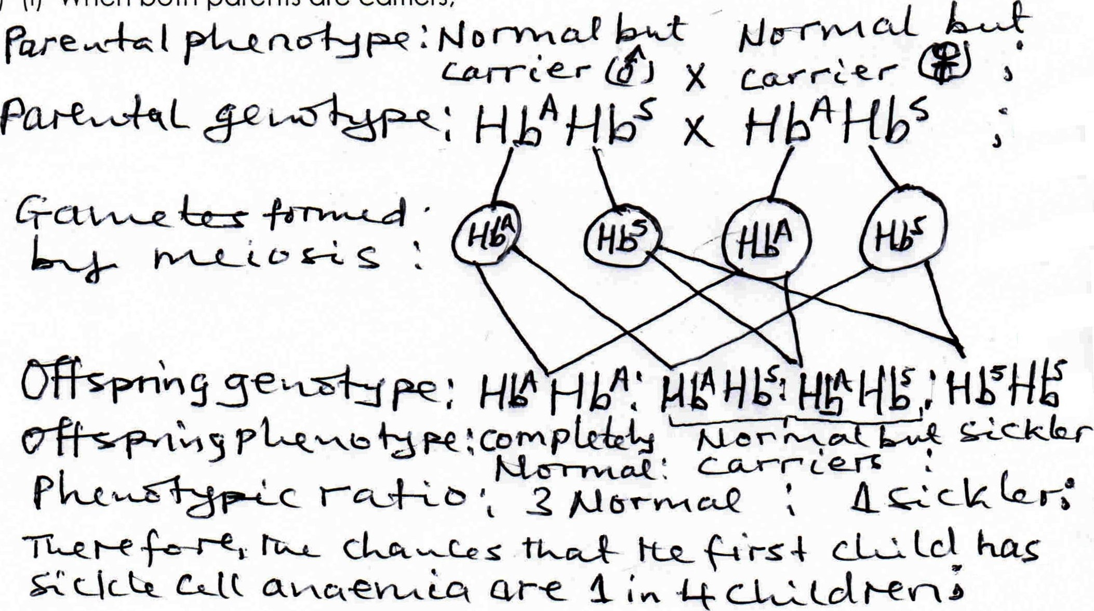

Accept also, a mating between a carrier female and sickler male parents. The chances of producing the first child with sickle cell anaemia from such a couple are I in 2 children.

1 mark @ 06 marks

(ii) The sickle cell allele is not easily eliminated because of heterozygous advantage/ balanced polymorphism;

Individuals who are HbAHbAand HbHbS are both phenotypically

normal but the heterozygotes /carriers are resistant to malaria; Therefore in an environment where malaria is the selection pressure ; completely normal

individuals are selected against while the carrier HbHbS are selected for or survive better; Therefore the allele for sickle cell anaemia (Hbs) are harboured by carriers; and these are capable of giving rise to offspring with sickle cell anaemia;

1 mark @ 06 marks

6.(a) Reactant in photosynthesis ,

Provide support to non-woody parts when epidermal cells take up water by osmosis and become turgid'

Medium of translocation and transport;

Cooling of plants when evaporated;

1 mark @ 4 marks

(b) (i) When soil temperature is warm there is increased uptake of water by osmosis ; and at very low temperature water absorption is reduced in plants;

Humidity of surrounding air of the leaves affects the rate of transpiration which in turn affects the rate of water absorption by the roots; water absorption is rapid when the humidity is low during dry days and windy days and transpiration is very high; The rate of absorption reduces during humid days when transpiration rate is low;

1 mark @ 5 marks

(ii) The leaf has intercellular spaces especially in the spongy mesophyll cells; in which vapour accumulates from the wet cells in the leaf; The leaf has numerous pores/ stomata; through which accumulated vapowr in the leaf escapes by diffusion;

The lead lamina is thin; this reduces the diffusion distance of vapour escape from intercellular spaces through stomata to the outside of the leaf; 1 mark @ 06 marks

# (c ) Similarities between sweatinq and transpiration

 Both involves evaporation of water vapour from the body;

 In both cooling effect to organism occurs;

 Both are affected by environment factors such as temperature;

# Differences between sweatinq and transpiration

|  |  |
| --- | --- |
| Sweatin | Trans iration |
| Secretion of sweat glands in response to increased temperature as a control Evaporation OCCUS from the external body surface.  Escape in fluid form from the sweat pores. | OCCUS as result of stomatal opening in presence of light for carbon dioxide up take; Evaporation OCCUS from cells inside the leaf;    Lost as water vapour through the stomata; |
|

1 mark : for an 5 marks

# TOTAL = 20 MARKS

1. 1/2 mark for any 16, 08 marks

   5. (a) Genetic disorder refers to an abnormal body condition/disease/ unfavourable condition caused by inheritance of a mutant gene; e.g sickle cell anaemia cawsed and expressed in recessive homozygous individuals.